Exp. 2 Design a LED Chaser

Circuit Diagram

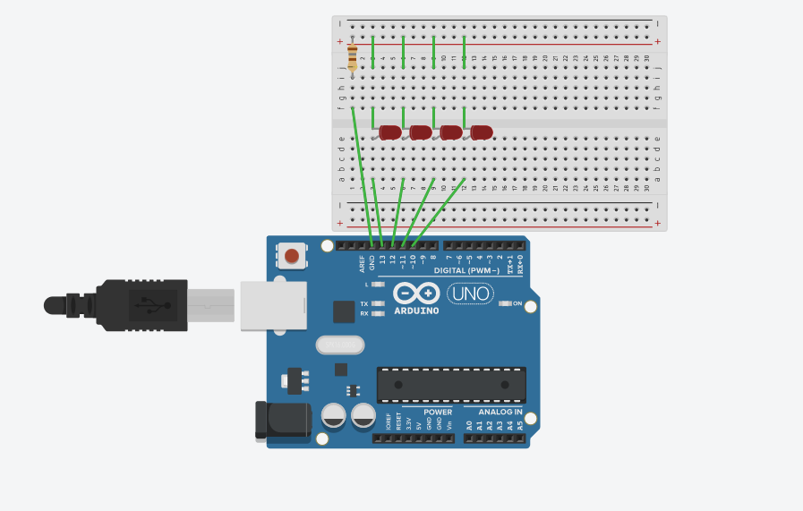

Theory

Concept used:

1. Ohm’s law

Ohm’s law states that the voltage across two points is directly proportional to the current flowing through the conductor and is inversely proportional to the resistance.

2. Breadboard

The holes in the rows at the top and bottom of the breadboard are connected in series and the ones in the columns are connected with each other. When LEDs are connected in parallel, voltage across them remains same.

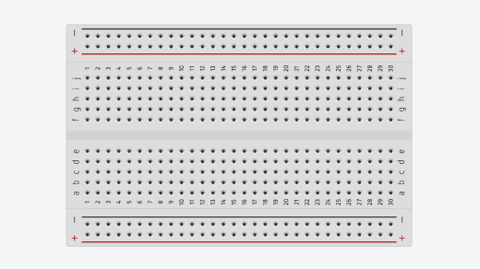

1. Arduino

The Arduino processes the code and converts it into electrical signal. The Arduino can supply 5V as power through the digital pins.

1. Kirchoff’s current law

No point in the circuit acts as source or sink of current. In other words, incoming current is equal to outgoing current.

Learning and observations

Learning

* I learned how parallel and more complex connections are made using breadboard.
* The digital pins (from 0-13) of the Arduino board can be used as both input or output pins. The analog pins can be used only as input.
* The anodes of the LEDs are connected to GND on the Arduino which acts as common ground for all negatives of the LEDs.

Observations

* The LEDs glow in the required output when the code is uploaded to the Arduino board. One LED blink once and then next LED blinks once and so on.

Problems and troubleshooting

* The connections were not tight. I had to make the connections tight.
* The circuit was not closed due to wrong connections of wires. I had to connect the wires properly.
* The code was not providing the required output. I had to make changes in the code.
* The LEDs were not connected to their respective pins. I had to connect them in a serial order. LED 1 was connected to 10, LED 2 to 11 and so on.
* The USB cable connecting the Arduino and the computer was worn out. I had to replace it with one that was working.

Precautions

* The connections should be tight and clean
* The LED should be appropriately connected, the cathode with the pin of Arduino and the anode with the ground.
* The correct port and board should be selected.
* The current flowing through the LED should not exceed the maximum limit. Use appropriate resistance.
* The anodes of all LEDs should have common ground.

Learning outcomes

* I have learned how to make circuits using Arduino and breadboard. I have now learned how to use multiple LEDs to get the necessary output.
* I have learned how to connect hardware to Arduino in a way so as to make it a parallel connection.
* I have acquired the skills needed to be able to make LEDs glow in various patterns.
* I have learned how to write code to make multiple LEDs glow in a required pattern.